# General

## Introduction and Intended Use (Informative)

This standard defines a multi-pole interface for vehicles with limited installation volume for electronic components. It is suitable for N and TT gauges, as well as smaller vehicle installations in HO gauge.

## References

This standard should be interpreted in the context of the following NMRA Standards, Technical Notes, and Technical Information.

### Normative

* S-9.1.1 DCC Interfaces, which specifies general DCC interface requirements
* S-9.2.3 DCC Service Mode, which specifies service mode programming requirements

### Informative

* TN-9.1.1.5 Next18 and Next18-S Decoder Interface, which provides commentary on the Next18 and Next18-S decoder interface
* TI-9.1.1 Sources for Connectors for DCC, which provides a list of manufacturer part numbers for DCC interface connectors
* TI-9.2.3 Serial User Standard Interface for DCC, which provides information on SUSI
* RCN-118 Decoder Interfaces Next18/Next18-S, with which this standard is intended to be in harmony[1]
* NEM 662 Electrical Interface Next 18, with which this standard is intended to be in harmony[2]

## Terminology

|  |  |
| --- | --- |
| **Term** | **Definition** |
| Vehicle | Mobile model railroad device. This includes locomotives and other rolling stock. |
| Decoder | DCC receiver for controlling vehicle animation. |
| System Board | Electronic circuit board that is considered part of the vehicle which a decoder is intended to be plugged into. |
| Train Bus | Serial User Standard Interface (SUSI) |

## Requirements

To meet this standard all mechanical and electrical values mentioned must be met and respected, unless otherwise noted. It is not necessary to implement all connections of the interface. The connections belonging to unimplemented features must remain unconnected. This applies to vehicles as well as for other devices that use this interface.

# Mechanical Properties

The interface consists of an encapsulated 18-pin socket (Figure 1) on the system board of vehicle and the encapsulated 18-pin header (Figure 2) on the decoder.

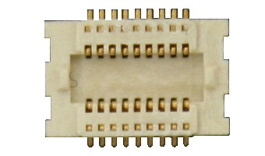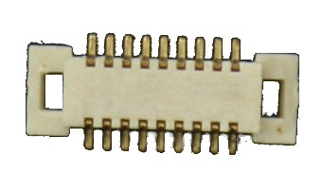

Figure 1: 18-pin socket

Figure 2: 18-pin plug

The electrical connections are arranged symmetrically to prevent damages if installed in a rotated orientation. However, the vehicle shall reserve space such that intended installation orientation is obvious.

The interface is divided into two installation volumes:

* Next18: electronic components (locomotive and/or function decoder) without sound
* Next18-S: electronic components (locomotive and/or function decoder) with sound

Table 1: Decoder dimensions

|  |  |  |  |
| --- | --- | --- | --- |
| **Dimension** | **Description** | **Next18**  **(without sound)** | **Next18-S**  **(with sound)** |
| a | Decoder length | 15.0mm | 25.0mm |
| b | Decoder width | 9.5mm | 9.5mm |
| c | Decoder height | 2.9mm | 4.1mm |
| d | Distance from edge of decoder to center of connector | 2.5mm | 2.5mm |
| e | Distance from decoder edge to assembly with max height of 0.5mm | 5.4mm | 5.4mm |
| f | Distance from decoder edge to assembly with max height of 1.5mm | 5.9mm | 5.9mm |

A decoder with the dimensions permitted for the Next18-S must provide a functional speaker connection.

The installation space in vehicle must be designed so that no components of the decoder touch bare metal parts or conductive traces. The installation space, dimensions according to Table 1 above, should be dimensioned so that the decoder fits into the installation space without pressure or constraint.

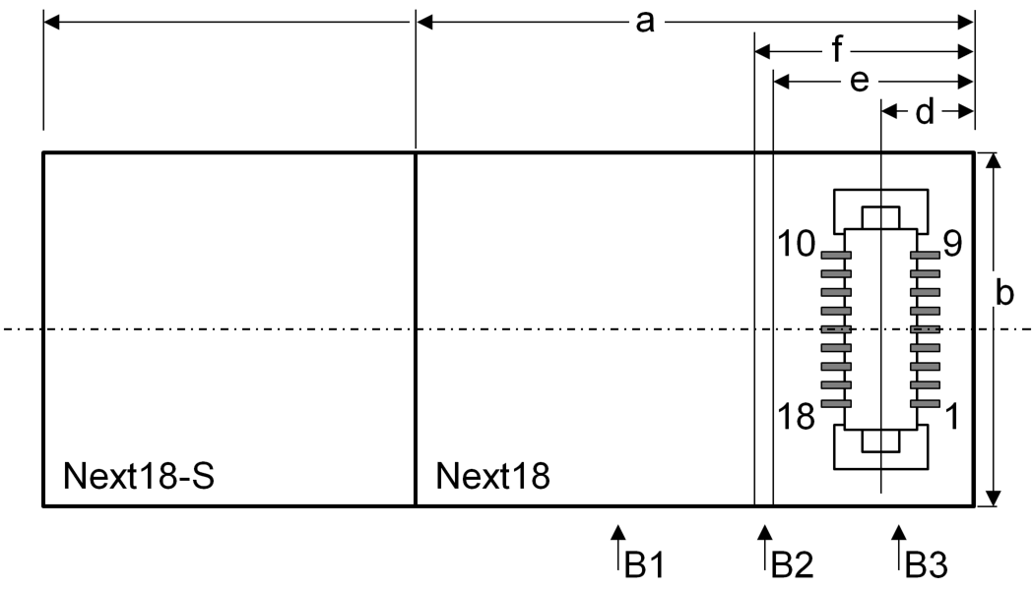

B1 = max 1.5mm permitted

B2 = max 0.5mm permitted

B3 = no assembly components allowed in this area

Figure 3: View from component side of connector

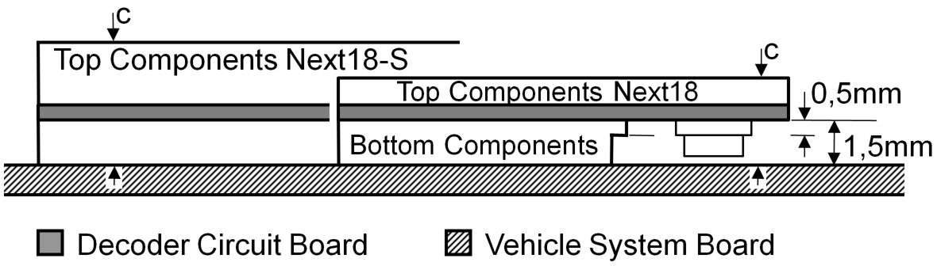

Figure 4: Decoder side view

The maximum assembly height of components on the bottom of the decoder is 1.5 mm. The placement height on the top of the decoder is calculated from the maximum decoder height minus the assembly height for bottom components (1.5 mm) and the thickness of the circuit board used.

## Plug Specification

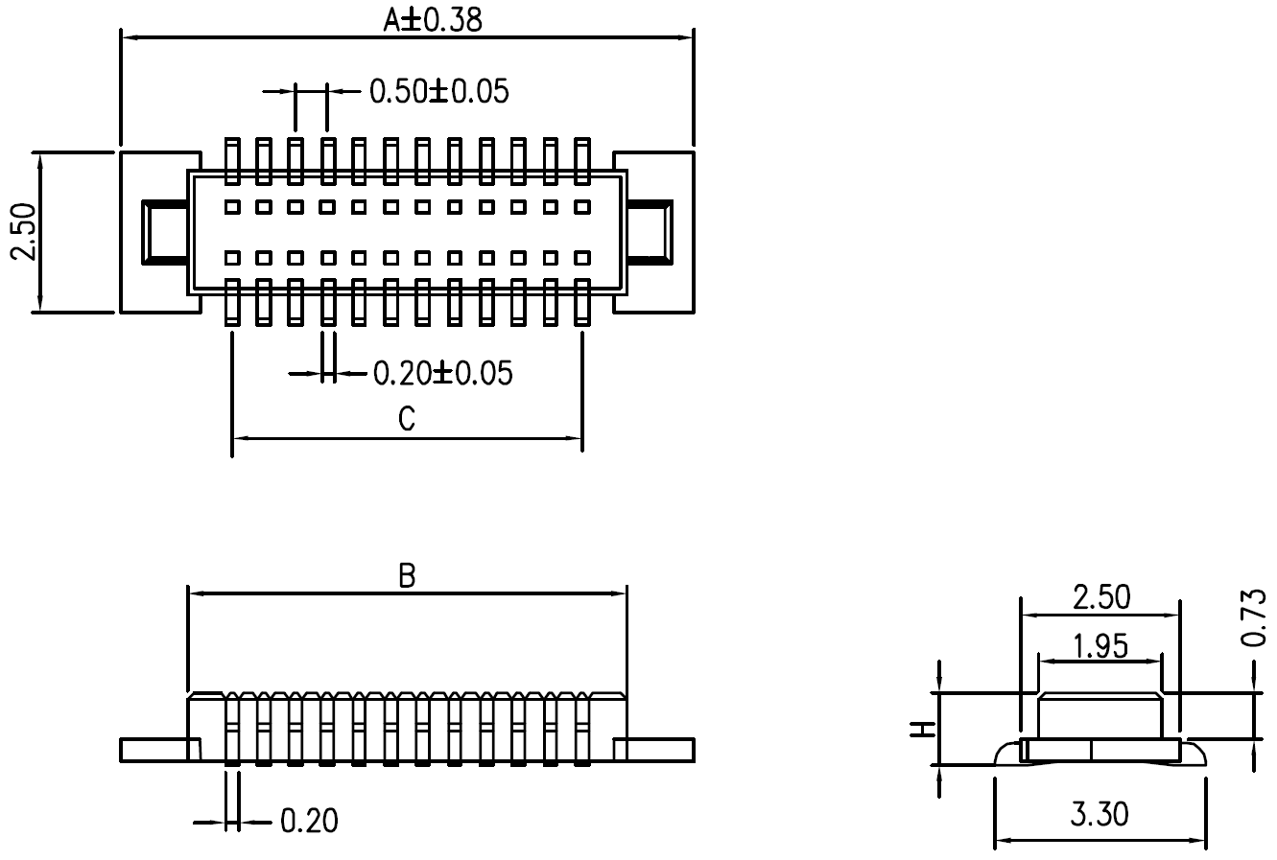

|  |  |  |  |
| --- | --- | --- | --- |
| **Contacts** | **Dimension [mm]** | | |
| **A** | **B** | **C** |
| 18 | 7.50 | 5.40 | 4.00 |

## Socket Specifications

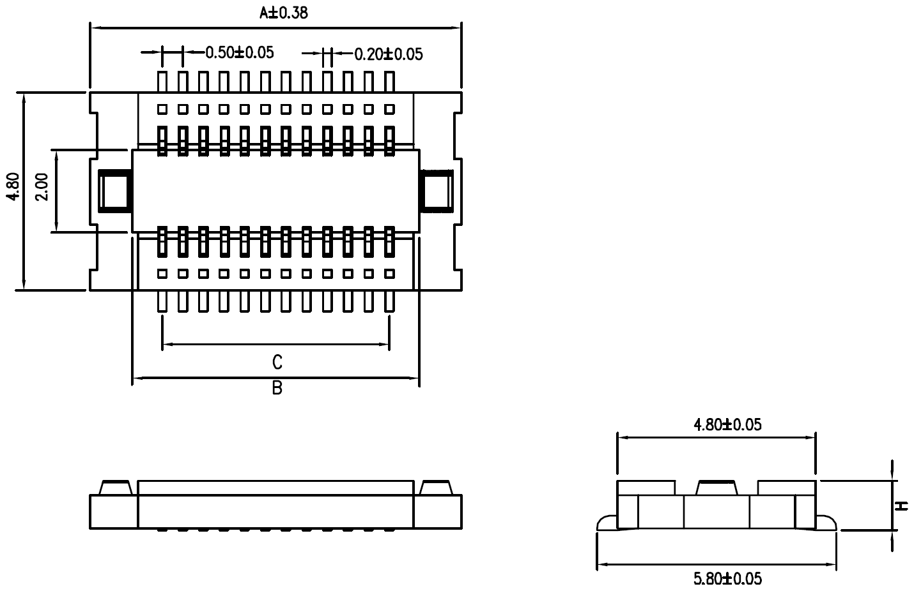

|  |  |  |  |
| --- | --- | --- | --- |
| **Contacts** | **Dimension [mm]** | | |
| **A** | **B** | **C** |
| 18 | 7.50 | 5.45 | 4.00 |

## Common Plug and Socket Specifications

**Material (Informative)**

1. Housing: High temperature plastic (94-V0)
2. Contact: Copper alloy (t = 0.2mm) Gold over nickel plating

**Specification (Normative)**

1. Current carrying capacity: 0.5A max
2. Insulation resistance: 1000MΩ at 500V DC
3. Dielectric strength: 150Vrms AC at 0.5mA for 1 minute
4. Contact resistance: 50mΩ max
5. Operating temperature: -40C to +105C
6. Maximum processing temperature (Informative): 230C for 30 – 60 seconds

# Electrical Properties

The contact rating is 0.5A. The track connections as well as V+ and GND (decoder plus and after rectifier) are each made with two contacts making their effective load capacity 1.0 A. The system board of the vehicle, as well as the decoder, must be designed so that if they make different use of the LS_A/AUX5 and LS_B/AUX6, no damage to the vehicle system board or decoder will occur.

## Next18 Pin Assignment

|  |  |  |  |
| --- | --- | --- | --- |
| **Pin** | **Name** | **Descriptions** | **Group** |
| 1 | Track Right | Track connection right rail | 1 |
| 2 | Motor + | Motor connection 1 plus / forward | 2 |
| 3 | AUX1 | Output 1 | 3 |
| 4 | AUX3/TBCLK | Output 3 | 4 |
| 5 | GND | Decoder ground, after rectifier |  |
| 6 | V+ | Decoder plus, after rectifier |  |
| 7 | AUX6 | Output 6 | 4 |
| 8 | F0F | Forward headlight | 3 |
| 9 | Track Left | Track connection left rail | 1 |
| 10 | Track Left | Track connection left rail | 1 |
| 11 | Motor - | Motor connection 2 minus / reverse | 2 |
| 12 | AUX2 | Output 2 | 3 |
| 13 | AUX4/TBDAT | Output 4 | 4 |
| 14 | GND | Decoder ground, after rectifier |  |
| 15 | V+ | Decoder plus, after rectifier |  |
| 16 | AUX5 | Output 5 | 4 |
| 17 | F0R | Reverse headlight | 3 |
| 18 | Track Right | Track connection right rail | 1 |

## Next18-S Pin Assignment

|  |  |  |  |
| --- | --- | --- | --- |
| **Pin** | **Name** | **Descriptions** | **Group** |
| 1 | Track Right | Track connection right rail | 1 |
| 2 | Motor + | Motor connection 1 plus / forward | 2 |
| 3 | AUX1 | Output 1 | 3 |
| 4 | AUX3/TBCLK | Output 3 | 4 |
| 5 | GND | Decoder ground, after rectifier |  |
| 6 | V+ | Decoder plus, after rectifier |  |
| 7 | Speaker B | Speaker connection B | 4 |
| 8 | F0F | Forward headlight | 3 |
| 9 | Track Left | Track connection left rail | 1 |
| 10 | Track Left | Track connection left rail | 1 |
| 11 | Motor - | Motor connection 2 minus / reverse | 2 |
| 12 | AUX2 | Output 2 | 3 |
| 13 | AUX4/TBDAT | Output 4 | 4 |
| 14 | GND | Decoder ground, after rectifier |  |
| 15 | V+ | Decoder plus, after rectifier |  |
| 16 | Speaker A | Speaker Connection A | 4 |
| 17 | F0R | Reverse headlight | 3 |
| 18 | Track Right | Track connection right rail | 1 |

## Description of Signals

Group 1 Track Right (pins 1 & 18) and Track Left (pins 9 & 10) are connected to the vehicle wheels for the incoming power supply.

Group 2 Motor + (pin 2) is normally connected to the right rail. Motor – (pin 11) is normally connected to the left rail if no decoder is present.

Group 3 These outputs are open collector/drain switched against ground on the decoder side. The voltage for the load comes from the Track voltage at V+ (pins 6 & 15). In the case where there are taillights connected separate from the headlights, the taillights in the forward direction (cab 1) are connected to AUX1 (pin 3) and the taillights in the reverse direction (cab 2) are connected to AUX2 (pin 12). Maximum load capacity is 100 mA per output.

Group 4 Outputs are defined as TTL/LVTTL logic-level according to Table 2 below. Maximum load 0.5 mA. If Train Bus is supported, the decoder must include a 470Ω series resistor on AUX3/TBCLK (pin 4) and AUX4/TBDAT (pin 13), and must have a 15KΩ (or greater) pull-up on TBDAT (pin 13) before the 470Ω series resistor. During startup, these decoder outputs may be briefly undefined. If this brief undefined state is critical to the system board operation, then precautions should be implemented on the system board. (AUX5/AUX6 NEXT18 only)

Group 5 The impedance of the speaker is 4Ω - 8Ω and must be documented by the decoder manufacturer. (NEXT18-S only)

If a voltage V+ is independently generated on the vehicle system board, it must not be connected to V+ (pins 6 & 15) of this interface.

Table 2: TTL/LVTTL voltage levels

|  |  |  |
| --- | --- | --- |
|  | **Decoder Output Voltage Level** | **System Board Input Voltage Level** |
| **Function switched off** | <= 0.4V | <= 0.8V |
| **Function switched on** | >= 2.4V | >= 2.0V |

## Use in Function Only Decoders

This interface can be used in vehicles without a motor. Since there is no motor connection in this case, the decoder must have an internal means of generating the required service mode acknowledgment as defined in S-9.2.3.

## Use of Interface with SUSI

This interface can also be used as a SUSI interface according to TI-9.2.3. In this case, only four signals may be used

1. GND (pins 5 & 14)
2. V+ (pins 6 & 15)
3. Train Bus Clock (pin 4)
4. Train Bus Data (pin 13)

In particular, the track connections are not to be used when wired as a SUSI interface. All other connections can be used for functions of the SUSI module.

## Operation without a decoder

For the operation of the vehicle without electronic components in the interface, a dummy plug must be used.

Minimal Dummy Plug Bridge plug with Bridge plug with functions

Functions F0F and F0R F0F, F0R, AUX1, and AUX2

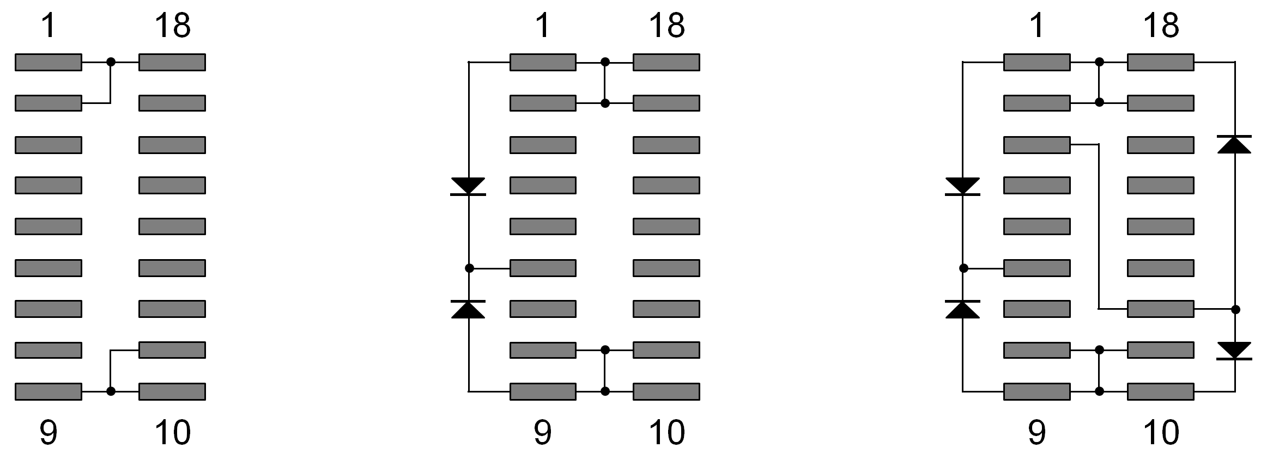

Figure 5: Typical dummy plugs

The typical bridge plug connects the following contacts

Track right: Motor +, F0R, (AUX1 if taillight included in forward direction)

Track left: Motor -, F0F, (AUX2 if taillight included in reverse direction)

Depending on the wiring of the function outputs in the vehicle, the vehicle manufacturer may setup a bridge plug specific to the vehicle if other outputs are connected. In the middle picture, outputs F0F and F0R are controlled depending on the direction. Functions AUX1 and AUX2 are always switched on in the picture on the right.

# Document History

|  |  |
| --- | --- |
| **Date** | **Description** |
| Oct 25, 2020 | First Revision |
|  |  |
|  |  |
|  |  |

**Important Notices and Disclaimers Concerning NMRA Standards Documents**

The Standards (S), Recommended Practices (RP), Technical Note (TN), and Technical Information (TI) documents of the National Model Railroad Association (“NMRA Standards documents”) are made available for use subject to important notices and legal disclaimers. These notices and disclaimers, or a reference to this page, appear in all standards and may be found under the heading "Important Notices and Disclaimers Concerning NMRA Standards Documents."

**Notice and Disclaimer of Liability Concerning the Use of NMRA Standards Documents**

NMRA Standards documents are developed within the Standards and Conformance Department of the NMRA in association with certain Working Groups, members, and representatives of manufacturers and sellers. NMRA develops its standards through a consensus development process, which brings together volunteers representing varied viewpoints and interests to achieve the final product. NMRA Standards documents are developed by volunteers with modeling, railroading, engineering, and industry-based expertise. Volunteers are not necessarily members of NMRA, and participate without compensation from NMRA.

NMRA does not warrant or represent the accuracy or completeness of the material contained in NMRA Standards documents, and expressly disclaims all warranties (express, implied and statutory) not included in this or any other document relating to the standard or recommended practice, including, but not limited to, the warranties of: merchantability; fitness for a particular purpose; non-infringement; and quality, accuracy, effectiveness, currency, or completeness of material. In addition, NMRA disclaims any and all conditions relating to results and workmanlike effort. In addition, NMRA does not warrant or represent that the use of the material contained in NMRA Standards documents is free from patent infringement. NMRA Standards documents are supplied “AS IS” and “WITH ALL FAULTS.”

Use of NMRA Standards documents is wholly voluntary. The existence of an NMRA Standard or Recommended Practice does not imply that there are no other ways to produce, test, measure, purchase, market, or provide other goods and services related to the scope of the NMRA Standards documents. Furthermore, the viewpoint expressed at the time that NMRA approves or issues a Standard or Recommended Practice is subject to change brought about through developments in the state of the art and comments received from users of NMRA Standards documents.

In publishing and making its standards available, NMRA is not suggesting or rendering professional or other services for, or on behalf of, any person or entity, nor is NMRA undertaking to perform any duty owed by any other person or entity to another. Any person utilizing any NMRA Standards document, should rely upon their own independent judgment in the exercise of reasonable care in any given circumstances or, as appropriate, seek the advice of a competent professional in determining the appropriateness of a given NMRA Standards documents.

IN NO EVENT SHALL NMRA BE LIABLE FOR ANY DIRECT, INDIRECT, INCIDENTAL, SPECIAL, EXEMPLARY, OR CONSEQUENTIAL DAMAGES (INCLUDING, BUT NOT LIMITED TO: THE NEED TO PROCURE SUBSTITUTE GOODS OR SERVICES; LOSS OF USE, DATA, OR PROFITS; OR BUSINESS INTERRUPTION) HOWEVER CAUSED AND ON ANY THEORY OF LIABILITY, WHETHER IN CONTRACT, STRICT LIABILITY, OR TORT (INCLUDING NEGLIGENCE OR OTHERWISE) ARISING IN ANY WAY OUT OF THE PUBLICATION, USE OF, OR RELIANCE UPON ANY STANDARD OR RECOMMENDED PRACTICE, EVEN IF ADVISED OF THE POSSIBILITY OF SUCH DAMAGE AND REGARDLESS OF WHETHER SUCH DAMAGE WAS FORESEEABLE.

**Translations**

NMRA’s development of NMRA Standards documents involves the review of documents in English only. In the event that an NMRA Standards document is translated, only the English version published by NMRA is the approved NMRA Standards document.

**Official Statements**

A statement, written or oral, that is not processed in accordance with NMRA policies for distribution of NMRA communications, or approved by the Board of Directors, an officer or committee chairperson, shall not be considered or inferred to be the official position of NMRA or any of its committees and shall not be considered to be, nor be relied upon as, a formal position of NMRA.

**Comments on Standards**

Comments for revision of NMRA Standards documents are welcome from any interested party, regardless of membership. However, **NMRA does not provide interpretations, consulting information, or advice pertaining to NMRA Standards documents.**

Suggestions for changes in documents should be in the form of a proposed change of text, together with appropriate supporting comments. Since NMRA standards represent a consensus of concerned interests, it is important that any responses to comments and questions also receive the concurrence of a balance of interests. For this reason, NMRA, its departments, Working Groups or committees cannot provide an instant response to comments, or questions except in those cases where the matter has previously been addressed. For the same reason, NMRA does not respond to interpretation requests. Any person who would like to participate in evaluating comments or in revisions to NMRA Standards documents may request participation in the relevant NMRA working group.

**Laws & Regulations**

Users of NMRA Standards documents should consult all applicable laws and regulations. Compliance with the provisions of any NMRA Standards document does not constitute compliance to any applicable regulatory requirements. Implementers of the standard are responsible for observing or referring to the applicable regulatory requirements. NMRA does not, by the publication of NMRA Standards documents, intend to urge action that is not in compliance with applicable laws, and NMRA Standards documents may not be construed as doing so.

**Copyrights**

NMRA Standards documents are copyrighted by NMRA under US and international copyright laws. They are made available by NMRA and are adopted for a wide variety of both public and private uses. These include both use, by reference, in laws and regulations, and use in private self-regulation, standardization, and the promotion of modeling, structural and engineering practices and methods. By making NMRA Standards documents available for use and adoption by public authorities and private users, NMRA does not waive any rights in copyright to the NMRA Standards documents.

**IMPORTANT NOTICE**

NMRA Standards documents do not guarantee or ensure safety, security, health, or environmental protection, or ensure against interference with or from other systems, devices or networks. NMRA Standards documents development activities consider research and information presented to the standards development group in developing any safety recommendations. Other information about safety practices, changes in technology or technology implementation, or impact by peripheral systems also may be pertinent to safety considerations during implementation of the standard. Implementers and users of NMRA Standards documents are responsible for determining and complying with all appropriate safety, security, environmental, health, and interference protection practices and all applicable laws and regulations.

1. RCN stands for RailCommunity Normen. The direct German to English translation of Normen is Norms and in this context is intended to have an equivalent meaning to Standards. RailCommunity is an organization of manufacturers that creates German language standards for model railway electronics.
2. NEM stands for Norms of the European Model Railroads. Norms, in this context, is intended to have an equivalent meaning to Standards. MOROP is the organization that maintains the NEM documents. MOROP is an organization that creates model railway standards primarily targeted at the European market.